May 26-28, 2017 | Capidalgo XXXV  Return to Treasure Island |  |  |  |  |  | At FYC  (Skyline)
 |  | 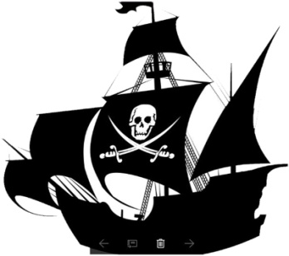
1. Reservations are due by May 5, 2017.  Send checks made out to FYC to:  Gib Moore  1315 30th St., Anacortes, WA 98221  Questions?  GibMoore@comcast.net  or  HeimgS@gmail.com  360 293 2749  §  2. Please email boat info to  Dock Master Red Bennett  360 488 3899  RangerTugRed@gmail.com  (LOA, beam, AC power, preferred side tie.) |  | Friday, May 26  10:30 Docking begins  11:00 – 14:00 Registration  16:00 – 2300 Bar opens  Treasure Meals for dinner  Saturday, May 27  08:00 – 10:30 Continental breakfast  09:30 – 13:00 Excursions to Anacortes and Swinomish Casino  14:00 – 16:00 Pirates’ Booty Rally  17:00 – 23:00 Bar opens  Buccaneers’ Ball  Paella feast  Dancing  Sunday, May 28  09:00 – 10:30 Bar opens  Hot breakfast, 50/50  10:30 – 11:30 – Skits, prizes,  closing ceremonies. |  |  |  | 3. Maties, make your  Excursion choice by  May 20, 2017.  Choice 1:  Downtown Anacortes: Farmers Market, Heritage Marine Center, Restaurants, Shopping, and more.  Choice 2:  Swinomish Casino and Two Salmon Café.  ↓  To reserve your spot in one of our cars, please email or call:  Joann Thornton  425 681 7391  Dennis Thornton  425 417 8003  DennisThornton@gmail.com
Welcome Ship: Pathways; VHF 68; Bill Monteforte and Kim Adams
Dinghies will escort arriving ships. Dock hands will be on duty.
Go home with a pile of loot!  50/50 tickets will be sold all three days. |  |  |  | Drink Tickets $3/ea (CAN/ US)  Beer: 1 ticket  Wine and hard stuff: 2 tickets  Call drinks: 2 tickets + $1 (CAN/US)
Welcome and check-in table will be at Skyline Marina Office.  10:30 – 2 PM. |  |  | US$68  Or  CAN$88 |  | For more info please visit:  FidalgoYachtClub.org → Calendar → Capidalgo XXXV
Capidalgo Coordinator: Joanne Wilshin, 360 707 1130; JoanneWilshin@gmail.com
A car will be available for transport from marina to clubhouse and back.

